

Cairo University

Faculty of computers and Artificial intelligence

Assignment I

Theater System Design and Analysis

Introduction to Software Engineering ( CS251 )

Name : David George Monir Noman

ID: 20201059

Name : Maher Mohsen Bahig

ID: 20200415

Section: S25/S26

**I. Functional and non-functional requirements :**

**I.I Functional :**

1. View Performance 2. Book Seat 3. Authenticate

4. Explore 5. Search 6. View offers

7. Join Waiting List 8. Add Seat to Cart 9. Check Out

10. Select Payment 11. Certify 12. Get Promo

**I.II Non-Functional :**

1. Restricted no. of clicks for unauthorized users to avoid useless / bot queries .

2. After a certain time if the integrated service (External identity provide) has no response reset the connection with it (**TIMEOUT**).

3. Recommend **Loyalty Points** if it is enough to book the seat(s)

4. Stability

5. Usability

6. Direct Access needed Functions ( Fewest no. of Clicks to get desired )

**II. Use case diagram :**

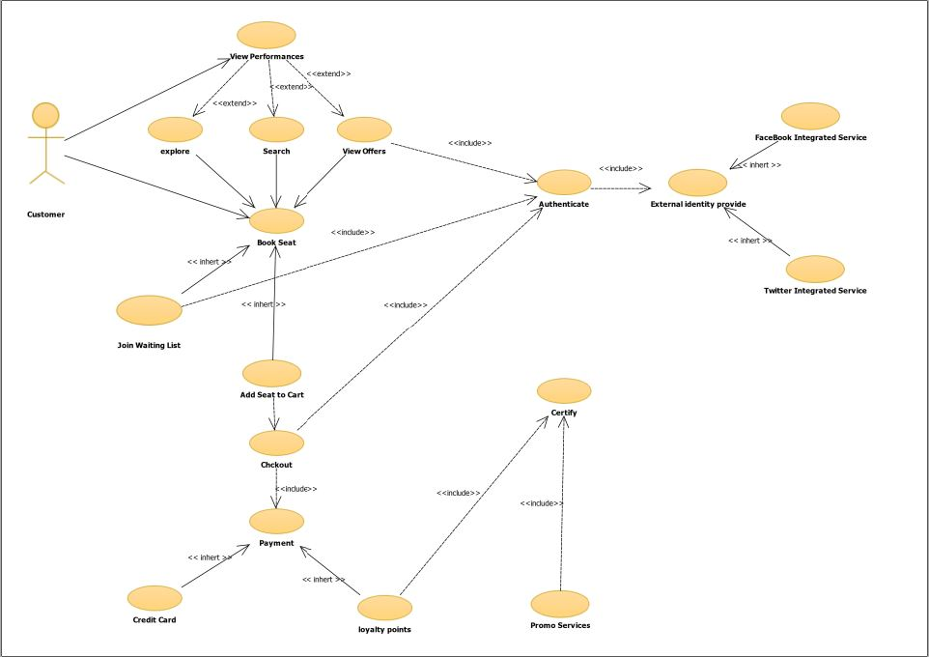

**III. Classes diagram :**

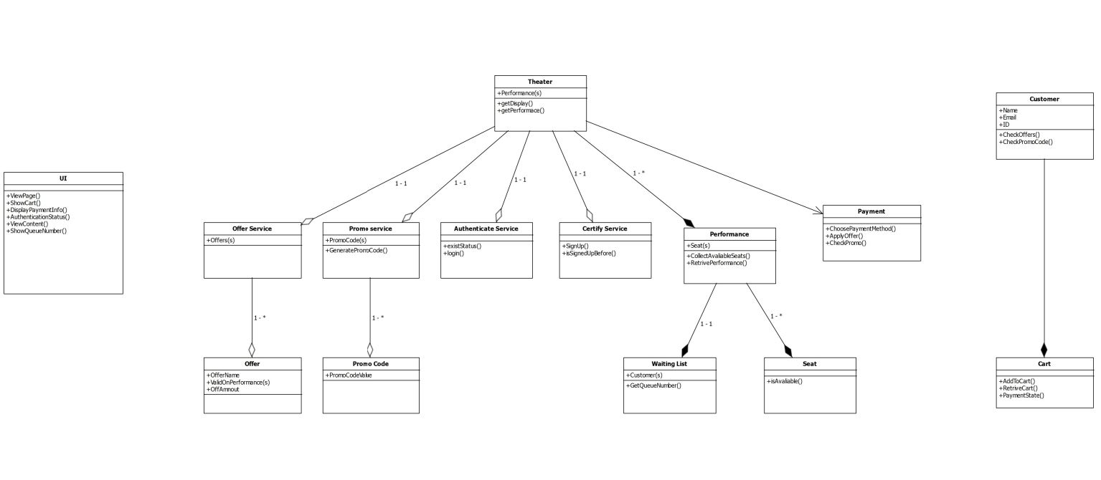

**IV. Use case descriptions/table :**

**1. View Performance(s)**

|  |  |
| --- | --- |
| Use case name | View Performance(s) |
| Participating Actors | Customer |
| Flow of events | Will display the performances that are offered by that theatre either by exploring , searching, or viewing offers . |
| Entry Condition [ Pre- ] | * When Customer only wants to find and see the performances that are offered by that theatre. * Customer opens Theater website page. * Click on View Performances button . |
| Exit Condition [ Post- ] | * Customer Either exploring , searching, or viewing offers [ under restricted conditions ] of theater performances . |
| Quality Requirements | * Restricted no. of clicks for unauthorized users to avoid useless / bot queries . |

**2 . Book Seat**

|  |  |
| --- | --- |
| Use case name | Book Seat |
| Participating Actors | Customer |
| Flow of events | 1. Select Desired Performance  2. Select Number of needed seat(s)  3. Select it’s / their position  4. Send to Cart on click. |
| Entry Condition [ Pre- ] | * When Customer only wants to find and see the performances that are offered by that theatre. * Only Booking Seats in performances that are offered by that theatre. |
| Exit Condition [ Post- ] | * Either adding this selected seat(s) to the buying cart * Or in case that needed seat(s) are not available then this customer may join the Performance’s Waiting list [ Under Restricted Conditions ] |
| Quality Requirements | * If directed to performance waiting list send customer a conformation mail of joining it |

**2.1 Basic Scenario :**

1. Customer opens Theater website page.

2. Click on View Performances.

3. Use exploring , searching, or viewing offers [ under restricted conditions ] .

4. pick a specific seat to book.

**2.2 Alternative Scenario :**

1. Customer opens Theater website page.

2. Click on Book Seat [ Directly ] .

3. pick a specific seat to book .

**3.Authentication**

|  |  |
| --- | --- |
| Use case name | Authentication |
| Participating Actors | Customer |
| Flow of events | 1. Customer gets to this point through anyone of different.   Scenarios.   1. The authentication page will be shown. 2. The choices that are provided to customer is either authenticate (Log in) through **FACEBOOK** or **TWITTER** services. 3. Then the customer will be directed to the integrated page of service of any of them to complete the authenticationprocess. |
| Entry Condition [ Pre- ] | * Being directed from any point of Website that require authentication grantee. |
| Exit Condition [ Post- ] | * The customer either logged in successfully or exceptional case take place (Integrated service respond). |
| Quality Requirements | * After a certain time if the integrated service (External identity provide) has no response reset the connection with it (**TIMEOUT**). |

**3.1 Basic Scenario :**

1. Customer opens Theater website page.

2. Click on Log in [ Authenticate ] .

3. Authenticate .

**3.2 Alternative Scenario :**

1. Customer opens Theater website page.

2. Click on View Performances.

3. Processed to Booking Seat.

4. Join waiting list .

5. Authenticate .

**3.3 Alternative Scenario :**

1. Customer opens Theater website page.

2. Click on View Performances.

3. Processed to Booking Seat.

4. Add to cart.

5. Click Checkout in cart side.

6. Authenticate .

**4. Checkout:**

|  |  |
| --- | --- |
| Use case name | Checkout |
| Participating Actors | Customer |
| Flow of events | 1. Customer presses the checkout button at cart page. 2. The cart has already selected seats (ready to be bought) 3. Customer will choose payment method either **Credit Card** or **Loyalty Points** [Under restricted conditions] |
| Entry Condition [ Pre- ] | * Cart is not empty. * Customer is authenticated. * Customer pressed the checkout button |
| Exit Condition [ Post- ] | Case 1(Successful):  A set of booking information  1- Verification ID  2- Performance Information  3- Reserved seat(s) Number(s)  Will be attached to an email and directed to the customer.  Case 2(Unsuccessful):  A failure mail will be directed to the customer with failure reason |
| Quality Requirements | * Recommend **Loyalty Points** if it is enough to book the   seat(s) |

**V. Create sequence diagrams :**

**1.View performance :**

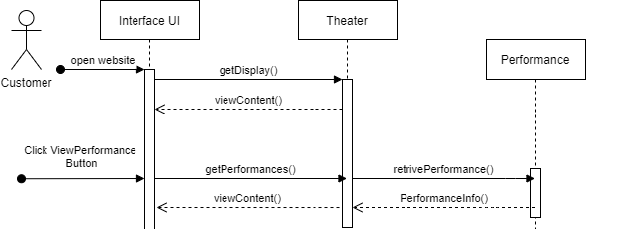

**2. Book Seat :**

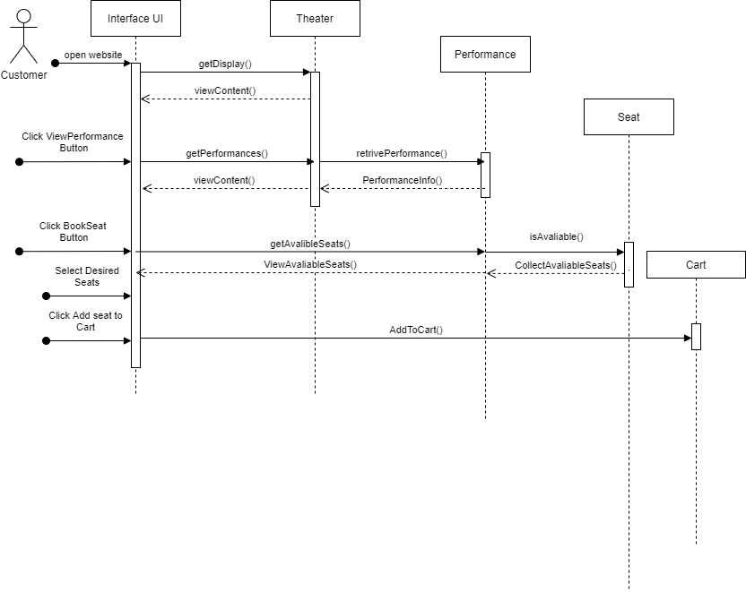

**3. Check out :**

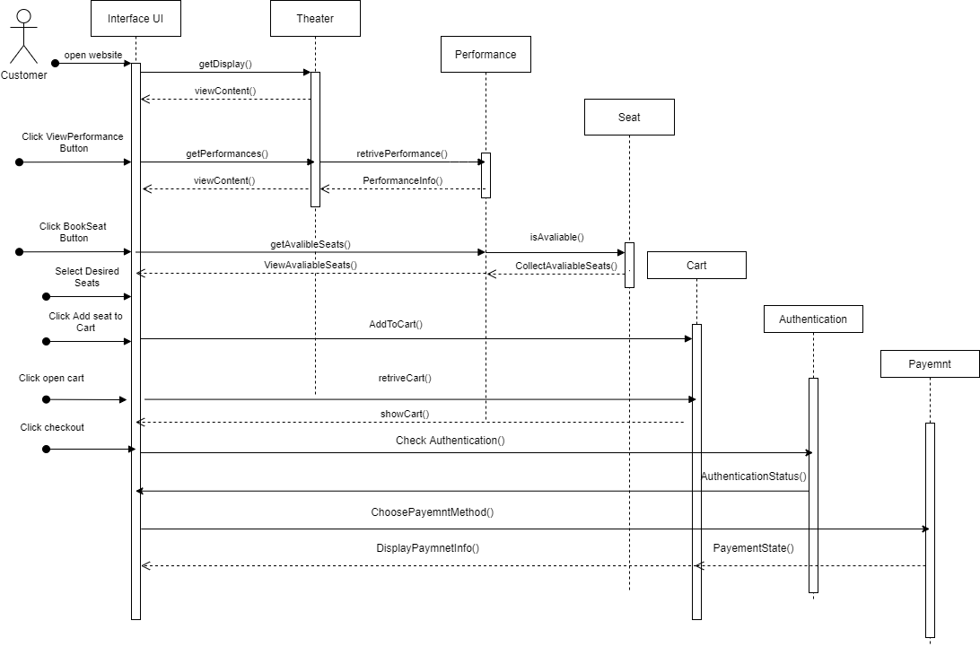

**4. Authentication :**

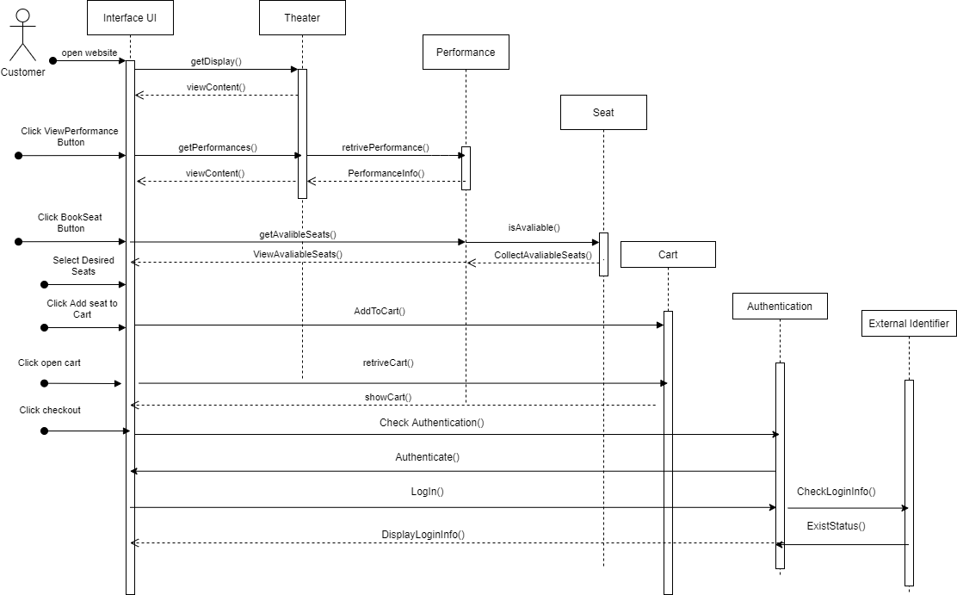

**THANK YOU**